P.2 LITERACY LESSON NOTES TERM III
WEEK 1
Going through the holiday work
Week 2
THEME 1:
Lesson 1
PEACE AND SECURITY

People who keep peace and security
a) At school
1. Guards
2. Teachers
3. Administrators
4. Children
5. None teaching staff

b) At home
1. Parents i.e. father or mother
2. Guards
3. Maids
4. Children
5. police officers

c) In the community
1. The police 4. The local council
2. The soldier 5. The religious leaders
3. The guards
Name these peace and security keeping people
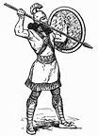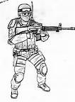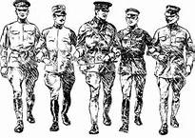 | 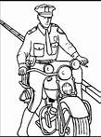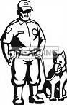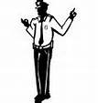
Soldiers | Police officers
Activity
- Child colours the people who keep peace and security.
- Mentions the people who keep peace and security at home, in the community and at school.

LESSON TWO
Roles of the people who keep peace and security
- The parents
- They provide security in their homes i.e.
a) By hiring guards
b) By putting fences around their homes.
c) By guiding their children.
d) By reporting wrong doers to the police officers.
- They provide basic needs. E.g. food, water, clothes, shelter, medical care

Activity:

Draw, name and colour these basic needs
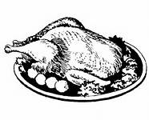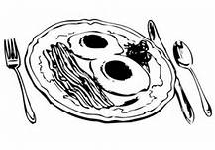  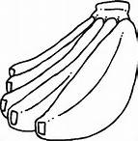 | 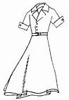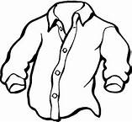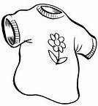 | 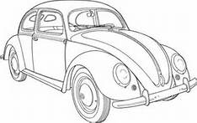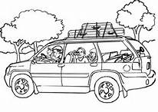  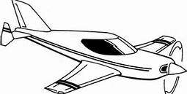
food | Clothes | transport
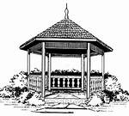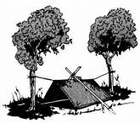  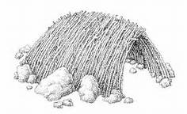 | 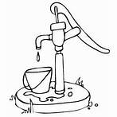  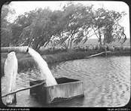 | 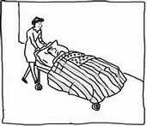  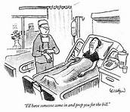
shelter | Water | Medical care

b) Teacher
- They help the children use the school rules and regulations.
Examples of school rules
- Put on proper school uniform.
- No fighting at school.
- No using abusive language.
- Bring to school only what’s necessary e.g. toys are not allowed
- Follow the school timings.
- They guide and talk to the children about their security.
- They guard children against bad people.
Activity:
Children mention some of class rules.

On assembly children are counselled and guided against bad people.
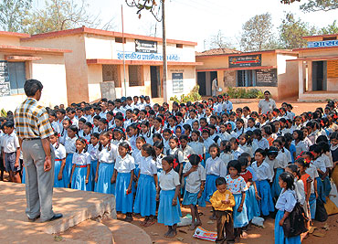
c) Children
- They obey rules and regulations.
- Listen to the teachers’/ parents’ instructions.
- Report strange people and things.
- Respect the school and home property.

d) Policewomen / men
- Keep law and order. – They control traffic on the road.
- Protect people and their property. – They put out fire.
- Arrest bad people. Or wrong doers. – They investigate crimes.
- Provide guidance and counseling.

Activity: child colours the roles of policemen and women
Roles of policemen and women
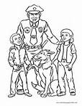 | 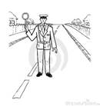
Protecting people | Officer on duty | Fire fighting

e) Religious leaders
- Preach the word of God to the people.
- Provide guidance and counseling.
- Encourage people to live in harmony.
- Pray for the people and the country.
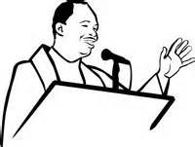 | 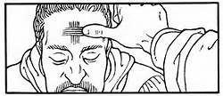
Preaching | Praying for people

LESSON THREE
Ways of promoting peace and security
- Counseling and guidance.
- Following rules and regulations.
- Listening and obeying instructions.
- Practicing religious norms.
- Praying for yourself and others.
- Forgiving people who have hurt you.

Sharing with others
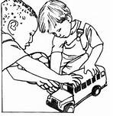 | 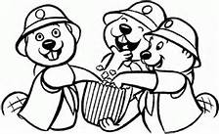

Why is it good to keep peace and security.
- For safety.
- Free movement of people, their goods and services.
- For freedom of speech.
- To carry out trade well.
- To protect people’s property.
- For Cooperation
- For love
- For respecting each other.

What happens if there is no security
- People can die.
- There is hunger. - People will be homeless.
- There will be loss of property. – There will be child abuse.
- Movement will be difficult for people and their goods.
Buildings destroyed during war.
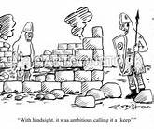 | 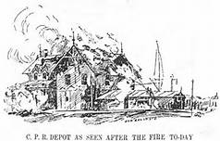 | 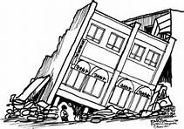

Things we can use to keep peace and security
- Dogs
- Cameras
- Cats
- Parrots
Lesson four
TOPICAL QUESTIONS
1. Write down any two people who keep peace and security.
a) At home a) parents b) maids
b) At school a) teachers b) guards
2. How useful are these people under peace and security in a community.
a) Reverend; preaches the word of God.
b) Soldiers; to keep peace and security in the country.
c) L.C chairman; to keep peace and security in the village.
3. Draw and name any two ways of keeping the security of a home.
Lesson five
THEME: CHILD PROTECTION
CHILD PROTECTION
Is to keep children safe from dangers
Ways of child protection.
- Bad people should be reported to police.
- Guidance and counseling lesson should be given to children.
- Educate the children about their rights.
- Children should report to their parents the bad things done to them.
- Children should make an alarm for help.
- Children should be encouraged to move in groups.
- Avoid dark corners.
- Children should be taken for education.
Activity;
- Child mentions ways of child protection.

SUB THEME: CHILD ABUSE
What is child abuse?
This is a way children are mistreated by adults.

People who can mistreat/ abuse children

- Parents - Drug users
- Witch doctors
- Teachers
- Strangers
- Relatives e.g. older brothers and sisters. Aunties Uncles, grandparents
Activity ;
- What is child protection?
- How do we call the way children are mistreated by adults?

Lesson six
Forms of child abuse
- Child labour. – Bad language
- Denial of basic needs - Beating the child
- Child sacrifice. - Burning the child.
- Child neglect. - Threatening the child.
- Child abduction / kidnapping. - Harassing the child.

Name these forms of child abuse.
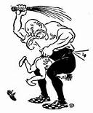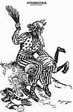 | 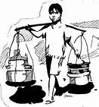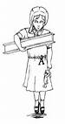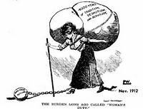
Beating a child | Child labour
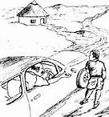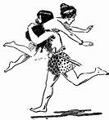 | 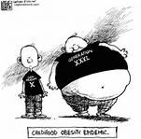
Kidnapping | Denying a child food

Lesson seven
Effects/results of child abuse
What happens if there is child abuse in the society / family/ community?
- Death - pain
- Hunger - Shame
- Fear - Hatred
- School dropouts - Sadness
- disability
- Loneliness -

One can be kidnapped while moving in lonely places.

Lesson eight
TOPICAL QUESTIONS
1. Write down any four forms of child abuse.
1. Burning children 2. Harassing children
3. Denying children food 4. Beating children
2. Who are the people most likely to do child abuse?
1. Parents 2. Teachers
3. Maids 4. Relatives
3. What is child abuse?
Is away children are mistreated by adults.
4. What can children do when one wants to kidnap them?
By making an alarm / running away / reporting to an adult.
5. List down 4 things which may happen if there is child abuse.
1. Death 2. School dropout
3. Fear 4. Hatred

THEME: Recreation, festival and holidays
Sub theme: Recreation
What is recreation?
Recreation is the way of spending ones leisure (free) time.
Recreation makes our mind and body relax.

Recreation activities at home
- Playing games _ Watching TV.
- Reading news / story books. _ Listening or telling stories.
- Swimming. _ listening to music.
- Partying / going for picnic. _ playing computer games.
Some children like playing games.
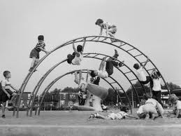 | 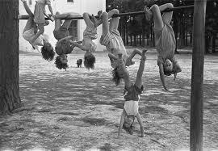
Recreation activities at school
- Resting - Listening to music
- Trips - Watching videos
- Playing computer games - Swimming
- Playing games - Reading story books.
- Dancing
Activity: children colours kids dancing and playing.
Dancing is liked and enjoyed by many children.
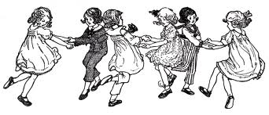 | 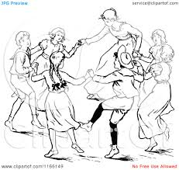
Places where people can go to relax their mind
- Beaches - Theatre
- Gym - stadium
- Game parks - Cinema halls
- Zoo - Field / play ground
- Swimming pools
- Recreation centres e.g Kiwatule, Wonder world, Kavumba etc……
Importance of recreation
Why do we go for recreation?
- To rest
- - To exercise
- To entertain
- For enjoyment
- For fun
- - For good health

SUB THEME: Festivals
Cultural festivals
What are cultural festivals?
These are celebrations different tribes do in their cultures.
Common cultural practices in our societies
- Naming of newly born children.
- - Marriage.
- Introduction.
- - Birth of twins.
- Funeral rites
- - Initiation
- Naming children
- Burial
Activity: child names the different cultural festivals
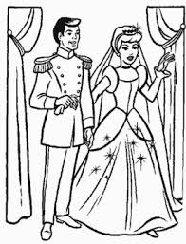 | 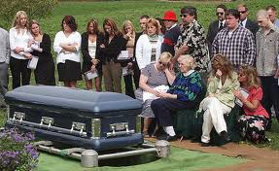 | 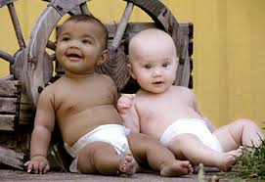
wedding | burial | Naming babies

- Naming children
- They can name according to situation.
- They can name according to the position in the family.
Name Tribe meaning
Mugeni Samya Fish
Musoke Baganda Rain
Natukunda Banyankole He loves us
Wasswa Baganda Elder twin
Kato Baganda Young twin
Kizza Bagannda Follower of twins
Kalugyendo Banyankole Born on the way
Mukama Basoga Small gods
Kafuko Basoga Following dead children

Activity : child answers these questions orally.
Write your cultural name?
____________________________________________
What is the meaning of your Cultural name?
_______________________________________________

SUB THEME : Initiation
Initiation is being allowed to become a member of a tribe / family.
Initiation practices
Practices Tribe
- Circumcision - Bagisu
- De-toothing - Alur
- Naming twins - All tribes
- Tattooing - Karamajong
Why do tribes initiate?

a) For recognition
b) For identification

Sub Theme: Holidays
A holiday is time when people are off their work.
Types of holidays
a) School holidays
b) National holidays / public holidays
c) Religious holidays.

1) School holidays
a) First term holiday
c) 3rd term holiday
b) 2nd term holiday

2) National / public holidays
These are given by the government to the whole country.
a) Liberation day - 26th Jan
b) Women’s day - 8th March
c) Labour day - 1st May
d) Heroes’ day - 9th June
e) Independence day - 9th October

3) Religious days
a) Easter Sunday - No particular date
b) Easter Monday - No particular date
c) Martyrs day - 3rd June
d) Christmas day - 25th December
e) Idd Mubarak - No particular date
f) Idd Elfitri - No particular date
g) Good Friday - No particular date

Importance of holidays
- For resting from to much work.
- For helping the parents at home.
- For praying to God.
- For remembering some people and honour them.
- For merry making.
- For visiting friends and relatives.

TOPICAL QUESTIONS
1. Give the meaning of these names;
a) Salongo - father of the twins to the Baganda.
b) Apio - a twin girl to the Iteso.
c) Mukisa - blessing to the Baganda.
2. Name any 4 places where people go for recreation.
a) Beaches b) zoo c) Theatres
d) Hotels e) cinema halls f) Swimming pools
3. Which tribe tatoes their foreheads?
Karamajongs
4. Which tribe practices circumcision of boys as a way of initiation?
Bagisu
5. List down any two religious holidays celebrated in a year.
a) Easter holidays b) Christmas holidays
6. Write down 2 things you do during your holidays.
a) swimming b)skipping c)playing football
7. Uganda got its independence on 9th October.
8. What do we call the chart that shows days, dates, weeks and months of the
year?
A calendar

